
3D Visualisation of Satellite Imagery
Prototype Report
Team Imagery
Damian Brockie
Rowan James
Shane Kingston
Matthew McKellar-Spence
Dafydd Williams

Image Window
This image window is where all the operations on the image are carried out. These operations will be panning, zooming and the effects of channel selections. Channel selections involve setting different bands of the image to different pixel colours. The result of these changes is shown by colour changes in the image.

Stage 1

Description
This prototype is meant to give an initial idea of what the image window is to include. This includes the menus for loading and saving the images in the image window. The scrollbars on the side of the screen are used if the image is too big to fit or if the image has been zoomed in otherwise they are greyed out and inactive. The window can be resized in the normal windows fashion. The name of the program and name of the open file is included in the title bar.
Stage | Previous Stage | Developer
1 | none | Dave
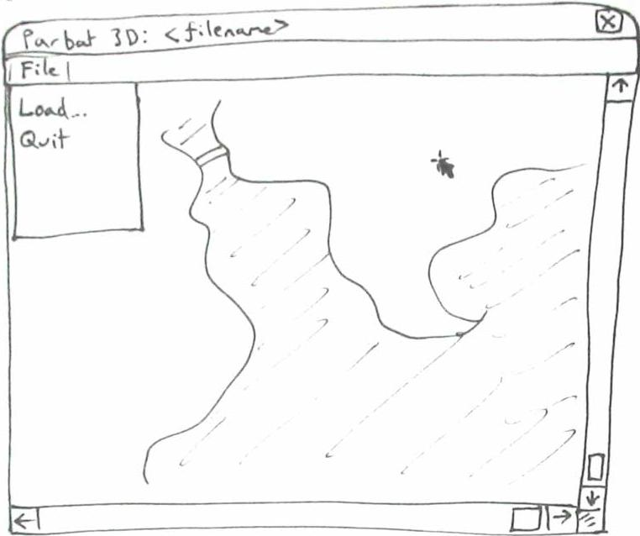

Feedback

Status
Another stage required

Stage 2

Description
Because the main window is no longer the image window in this prototype the menus needed to be shifted to another window. In this prototype they are located in an overhanging window rather than the image one. To give a better idea of what operation the user is currently carrying out, a context-dependant cursor has been added. The cursor icon will change depending on what the user is doing, such as resizing, panning or zooming. Because this window is no longer the main one the name of the program can be removed from the title bar.
Stage | Previous Stage | Developer
2 | 1 | Damian
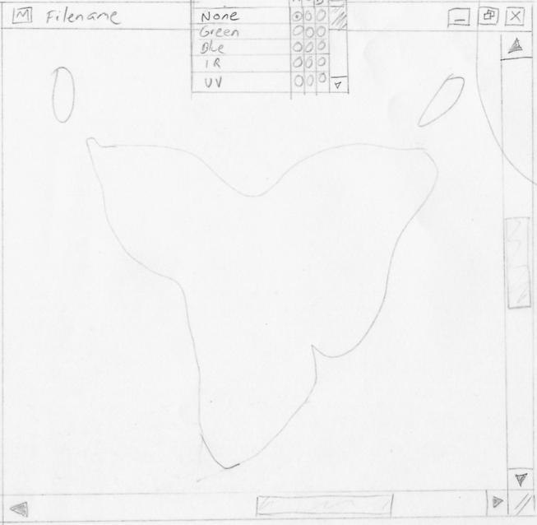

Feedback

Status
Another stage required

Stage 3

Description
This prototype was created to give an idea of how the image window will look like in the final product by making an executable prototype. To simplify what is shown in the window the context-dependant cursor was removed.
Stage | Previous Stage | Developer
3 | 2 | Shane
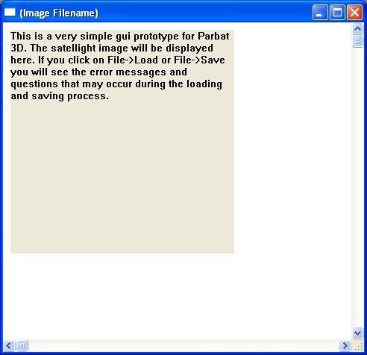

Feedback

Hugh Barker (Krill) on 6/4/2006
- Like MDI but better & less cluttered if prototype could be maximised. Zooming etc not immediately obvious.

Michael Ford (BioDiv) on 5/4/2006
- “Where will (the toolbar) be located? Will the tools be like standard toolbars on the left of the screen?”

Rod Palmer (DSMS) on 11/4/2006
- “Maybe needs some kind of menu bar for consistency”

Status
Another stage required

Stage 4

Description
This prototype was created as a result of going back to the original idea of having separate windows instead of an overhanging one. This means that the menus are back in the image window instead of the overhanging one. A live display of pixel values under the cursor and its location are shown in the pixel query window but, to give greater visibility, this prototype also includes these values in the image window status bar. Because the image window is now the main one again the title bar includes the name of the program and the open file’s name.
Stage | Previous Stage | Developer
4 | 1 | Matt
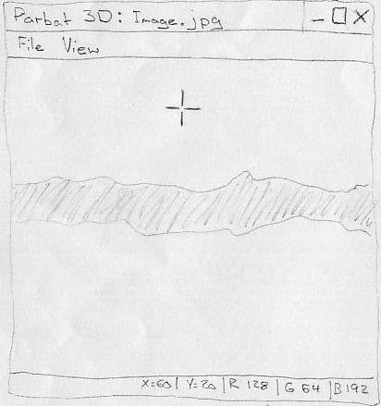

Feedback

Michael Ford (BioDiv) on 5/4/2006
- “The cross hair cursor is good”

Rod Palmer (DSMS) on 11/4/2006
- “Shows file (name) and status bar (which is good)”
- “Might be a good idea to have a progress bar when loading images”

Stuart Cook (BioDiv) on 6/4/2006
- Pixel summaries in status bar are good since always visible but still have a separate pixel query window.

Status
Approach abandoned

Stage 5

Description
Although this prototype is keeping with the idea of having separate windows, the main window (including menus) has been shifted to the overview window. This prototype also uses the status bar but now has a loading bar that shows how much of the image has been loaded.
Stage | Previous Stage | Developer
5 | 3 | Rowan
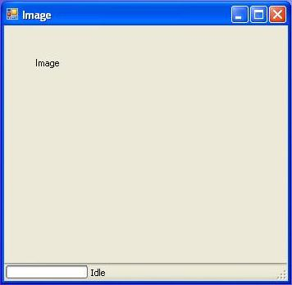

Feedback

Thai Nguyen (GetSet) on 10/4/2006
- “The window is resizable and has a progress indication (which is good)”
- “Have the progress bar on the right side of the window menu in image window”

Vanessa Wronski (Krill) on 5/4/2006
- “Nice placement of the window, being top left makes it look like it is the main window”
- “The buttons to minimise, maximise and close the window should be smaller that the buttons of the main programs window. The size of the window needs to be bigger, won’t see much of the image otherwise”

Status
Another stage required

Stage 6

Description
To simplify the display, this prototype goes back to the ideas from stage 3 to remove extra features from the image window and make more space for the image. Only the features necessary for displaying the image and performing operations such as panning, zooming and window resizing are included.
Stage | Previous Stage | Developer
6 | 3 | Whole Team
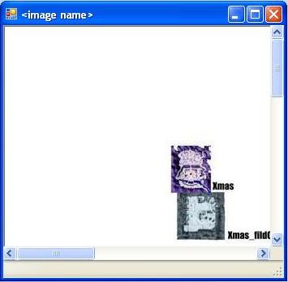

Feedback

Status
Approach abandoned

Stage 7
The cursor location from stage 4 and the loading bar from stage 5 were considered important enough to be included in the status bar, so they have been reintroduced in this prototype.

Description
Stage | Previous Stage | Developer
7 | 5 | Whole Team
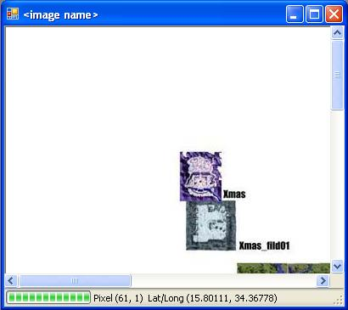

Feedback

Status
Approved by most people and finished

Overview Window
The overview window contains a small thumbnail of the entire image that has been loaded into the image window. Because images that are loaded into the program will normally be too big to fit in the image window, the overview window lets the user see the image in its entirety. The part of the image that is displayed in the image window will be shown in the overview window by containing it in a bounding box.

Stage 1

Description
This is the initial overview window prototype and was created to provide a basis to work from. This prototype needed to implement a thumbnail of the entire image and the bounding box for showing what is contained in the image window.
Stage | Previous Stage | Developer
1 | none | Damian
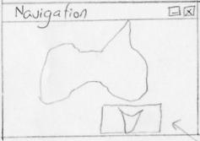

Feedback

Status
Another stage required

Stage 2

Description
This executable prototype was created to give an idea of what the overview window would look like in the final version. This version does not include a bounding box for what is displayed in the image window.
Stage | Previous Stage | Developer
2 | 1 | Shane
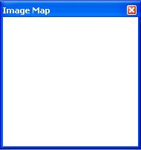

Feedback

Nicolas Grubb (BioDiv) on 6/4/2006
- “I like the ability of the zoom, pan, etc features in both pictorial views”

Francis Chui (Krill) on 6/4/2006
- “(I) like the zooming facilities”

Status
Approach abandoned

Stage 3

Description
This prototype was created based on stage 1 and the only changes that it includes are a name change of the title from “Navigation” to “Overview”.
Stage | Previous Stage | Developer
3 | 1 | Matt
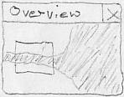

Feedback

Michael Ford (BioDiv) on 5/4/2006
- “Overview window is functional and has a good name”

Rod Palmer (DSMS) on 11/4/2006
- Small scale overview which allow easy selection of large maps (is good)”

Status
Another stage required

Stage 4

Description
This executable prototype is based on stage 3 but has some major changes. In the previous stages the image window was the main window but in this stage the overview window has become the main one. Because of this the title now contains the program name and all the menus are now located in this window. An image toolbar has been introduced into this prototype and is located below the menus in the window.
Stage | Previous Stage | Developer
4 | 3 | Rowan
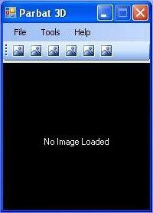

Feedback

Matt McKellar-Spence on 11/4/2006
- Extra icons in toolbar not necessary. The menu feels better in the image window.

Thai Nguyen (GetSet) on 10/4/2006
- “A small preview of the image (is good)”
- “(I am concerned) about the size (it) may look like a tool application, perhaps make it bigger than other tool windows”

Vanessa Wronski (Krill) on 5/4/2006
- “Nice layout of menu options. Usability of the menu is consistent with most programs”

Status
Another stage required

Stage 5

Description
This stage contains only small adjustments to stage 4. The main problem that needed to be solved was that of the image toolbar not being relevant in the overview window, so it was removed. Also a minor change was the “Tools” menu being renamed to the “Windows” menu in order to better relate to its contents.
Stage | Previous Stage | Developer
5 | 4 | Whole Team
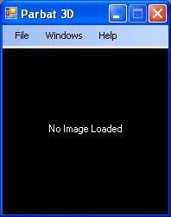

Feedback

Status
Approved by most people and finished

Channel Selection Window
The channel selection window allows the user to change what channels are assigned to what pixels. This means that the user is meant to be able to set different channels to the red, green and blue pixels. There should also be the option of displaying the image in greyscale by setting all the pixel colours to one channel.

Stage 1

Description
This initial prototype allows the channels to be set to pixels using radio buttons. One of the problems with this is that the window is very compact so it is hard to make out the controls.
Stage | Previous Stage | Developer
1 | none | Dave
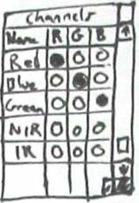

Feedback

Francis Chui (Krill) on 6/4/2006
- “Radio buttons for reflection is good for displaying the channel that was selected”

Stuart Cook (BioDiv) on 6/4/2006
- Easy to see which channels are set to what
- Not clear whether radio buttons associate horizontally or vertically – stronger vertical lines should help.

Abdal Chambal (eXation) on 6/4/2006
- Channels displayed with radio buttons is good

Status
Another stage required

Stage 2

Description
This prototype is based on stage 1 but fixes the problem of not having enough white space to make it easy to read. Another problem that has arisen is the fact that it is hard to tell at first if the radio button selection is done horizontally or vertically. This selection is meant to be done vertically but since radio buttons typically are selected horizontally this can make initial selections unclear.
Stage | Previous Stage | Developer
2 | 1 | Damian
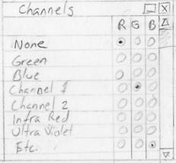

Feedback

Status
Another stage required

Stage 3

Description
This prototype goes in a different direction to the previous stages and uses drop boxes instead of radio buttons for channel selection. This makes it more obvious as to how selections are made and makes it more compact. It doesn’t matter how many channels there are, the channel selection window will always be the same size. There is the problem that the drop boxes force the user to make extra mouse clicks and movement to select channels and it is not instantly visible what channels are available.
Stage | Previous Stage | Developer
3 | none | Shane
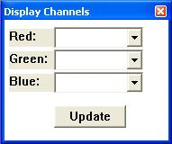

Feedback

Nicolas Grubb (BioDiv) on 6/4/2006
- “The radio buttons seems to be the way to go”

Abdal Chambal (eXation) on 6/4/2006
- Replace drop down menu with radio buttons – user might be lost

Stuart Cook (BioDiv) on 6/4/2006
- Drop-down menus save space & simple to use
- Can’t see all settings at once – if have boxes next to each other, opening one wouldn’t hide the others. Can’t see at a glance what channels are available – perhaps add list of them above/below selectors.

Status
Another stage required

Stage 4

Description
This prototype keeps with stage 3 by continuing to use drop boxes. To make the display even more compact the pixel query window has been merged with the channel selection window. The values of the pixels under the cursor are shown alongside the drop boxes meaning that an extra window is not necessary. The location of the cursor, which was shown in the pixel query window, has been moved to this window also.
Stage | Previous Stage | Developer
4 | 3 | Matt
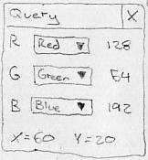

Feedback

Status
Approach abandoned

Stage 5

Description
This prototype implements the radio button selections from stage 2 in an executable form. The problem of not knowing which axis the radio buttons selection takes place along is fixed by grouping each of the pixel colour groups using boxes. An extra feature that has also been implemented is the “Default” button. Since most of the time users will want to set the red channel to the red pixel, blue to blue and green to green, the default button will let the user do this with a single button click.
Stage | Previous Stage | Developer
5 | 2 | Rowan
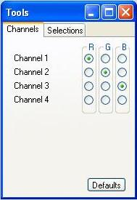

Feedback

Leigh Milbourne (DSMS) on 6/4/2006
- “Radio buttons (are) a good idea”

Thai Nguyen (GetSet) on 10/4/2006
- “Tabs are really good”
- “Change heading channel to RGB values or something similar”
- “Add apply button”

Vanessa Wronski (Krill) on 5/4/2006
- “Great visibility, good layout of menus and button. Great dimming of the blue colour of the menu bar.”

Status
Another stage required

Stage 6

Description
This prototype makes some minor changes to stage 5. Such as removing the “Default” button, which was unnecessary, and adding a “NONE” channel and an update button. The “NONE” channel allows users to not use one of the pixel colours. If the image only has 2 channels then the “NONE” channel means that one channel doesn’t have to be set to 2 pixel colours. The update button allows users to select channels by the radio buttons and then update the image when they are ready rather than having it done automatically each time they choose a different radio button.
Stage | Previous Stage | Developer
6 | 5 | Whole Team
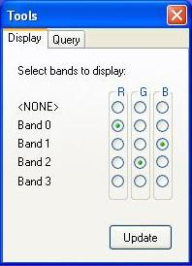

Feedback

Status
Approved by most people and finished

Pixel Query Window
As the user moves the mouse over the image in the image window there needs to be a live display of the values of the channels in the image. These values will need to be retrieved from the image and then displayed in the pixel query window alongside the appropriate channel names.

Stage 1

Description
This initial prototype was done as a basis for others to come. Only the values of the channels set to the red, green and blue pixels are shown as a live display. This is a bit limited but does speed up the calculations. The location of the screen cursor is also shown.
Stage | Previous Stage | Developer
1 | none | Dave
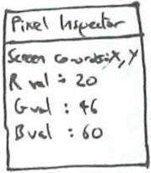

Feedback

Francis Chui (Krill) on 6/4/2006
- “Similar layout to Photoshop (is good)”
- “Could have specific coordinate entry”

Abdal Chambal (eXation) on 6/4/2006
- Pixel inspector could have scroll bar & change name to ‘query’

Status
Another stage required

Stage 2

Description
This prototype improves on stage 1 by including more than just the RGB channel values. This would give more information to the user but would take a bit longer to perform the calculations
Stage | Previous Stage | Developer
2 | 1 | Damian
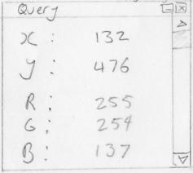

Feedback

Michael Ford (BioDiv) on 5/4/2006
- “Docking query window limits amount of data available to view. Needs a status bar.”

Status
Another stage required

Stage 3

Description
To give the user even more information of what was being displayed, the channels that had been set to pixel colours now have the names of those colours alongside them. This makes it even quicker for the user to see what a channels value is based on the colour of the pixel.
Stage | Previous Stage | Developer
3 | 2 | Shane
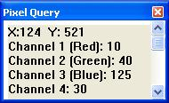

Feedback

Michael Ford (BioDiv) on 5/4/2006
- “Wealth of information (is good)”
- “Pixel query needs to be larger to see all data?”
- “(Does the) pixel query show visible channels on top?”
- “If docking will it show all data (or) only visible values?”

Status
Another stage required

Stage 4

Description
This prototype stage was testing a different form of layout and combines the channel selection and pixel query windows. This makes the display more compact and means there is only one window the user has to check when interested in channel values and selection.
Stage | Previous Stage | Developer
4 | none | Matt

Feedback

Michael Ford (BioDiv) on 5/4/2006
- “Showing query values alongside channel selection are limiting, what about non-visible channel values? Perhaps needs a container window.”

Stuart Cook (BioDiv) on 6/4/2006
- Pixel query & channel selection in same window seems confusing & unnecessary

Status
Approach abandoned

Stage 5

Description
This prototype uses the idea from stage 4 of saving screen space by combining channel selection and pixel queries in one window but also allows the better visibility of the other stages by including the pixel query and channel selection under different tabs.
Stage | Previous Stage | Developer
5 | 3 | Whole Team
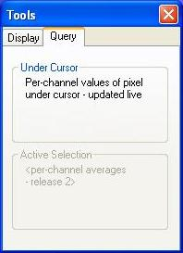

Feedback

Status
Approved by most people and finished

All Windows
This prototype series decides what windows need to be displayed and how their layout on the screen. The windows need to give the user all the information needed and but not waste too much screen space.

Stage 1

Description
This was the first sketch of the window layout and has the image window as the main window with the channel selection and pixel query windows as utility windows alongside this.
Stage | Previous Stage | Developer
1 | none | Dave
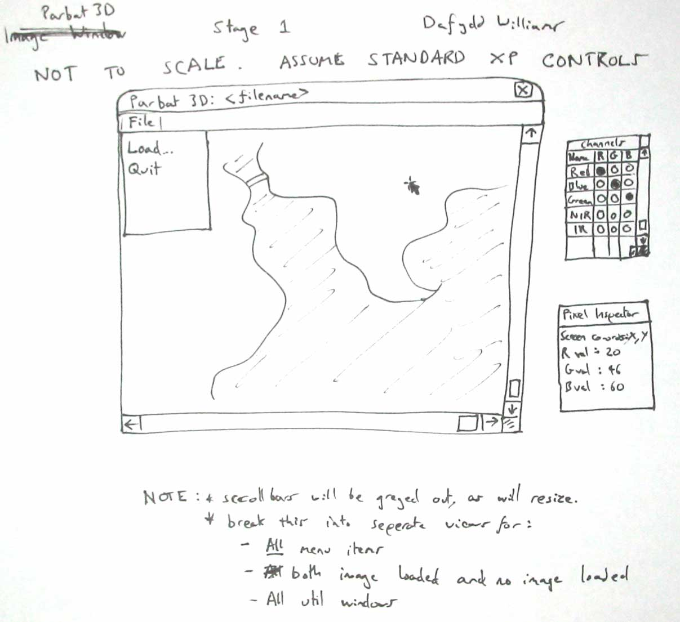

Feedback

Karl Fischman on 6/4/2006
- Floating toolboxes are good

Abdal Chambal (eXation) on 6/4/2006
- Should have help menu and/or about

Hugh Barker (Krill) on 6/4/2006
- Like the sperate floating windows

Status
Another stage required

Stage 2

Description
The previous approach could end up with the screen becoming cluttered with all the utility windows so to fix this problem this prototype includes all the windows in an overhanging window. The overhanging window now becomes the main window and now contains the menus that were in the image window. This prototype also introduced the overview window that is helpful when the image is too big for the image window. Another feature used to reduce clutter in this stage was the ability for the utility windows to be minimised into toolbars.
Stage | Previous Stage | Developer
2 | none | Damian
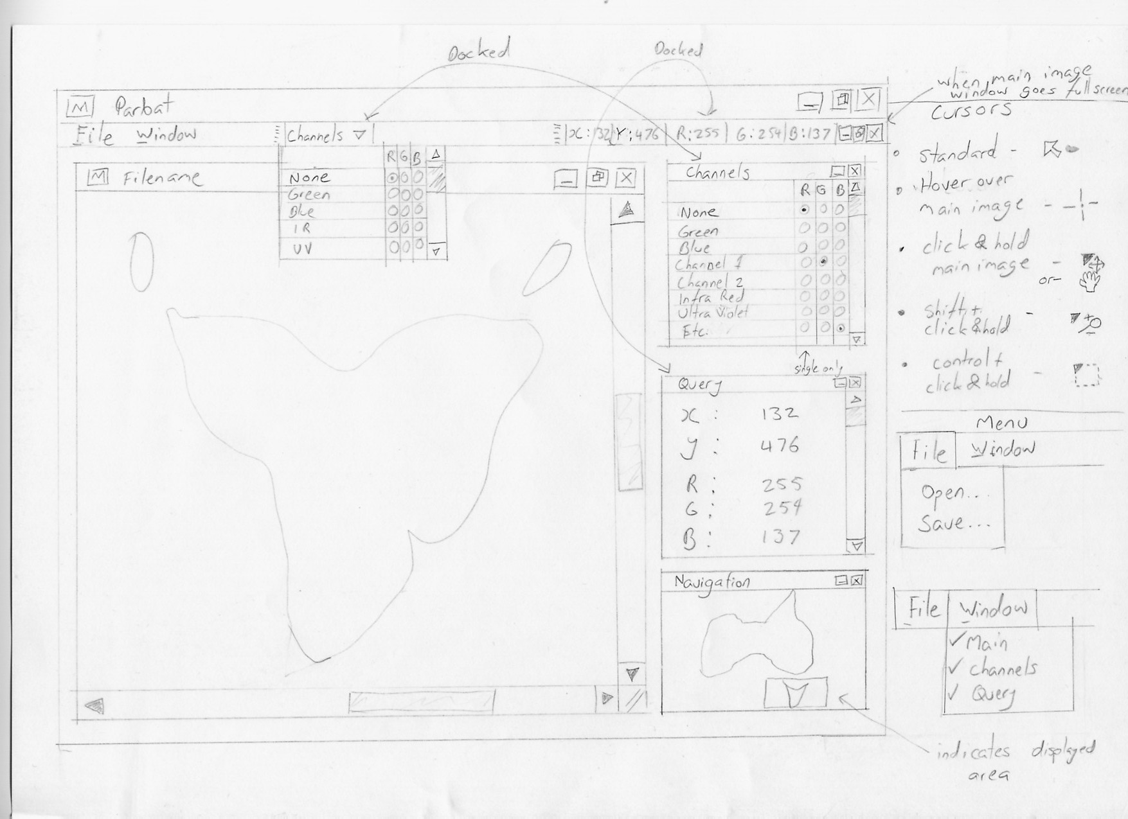

Feedback

Nick Roberts on 6/4/2006
- Very well laid out & good design

Van Thien Vu on 6/4/2006
- Design preferred than other GUIs

Karl Fischman on 6/4/2006
- More detailed is good
- A little cluttered – space things out a bit

Abdal Chambal (eXation) on 6/4/2006
- Help menu is good

Stuart Cook (BioDiv) on 6/4/2006
- Docked toobars/boxes - cool idea. Separate mouse cursors for different tasks.
- Docked toobars/boxes too confusing in practice – ordinary tool windows/sidebars probably better.

Hugh Barker (Krill) on 6/4/2006
- Docking may complicate the UI

Status
Another stage required

Stage 3

Description
This stage puts the previous prototype into an executable form along with a few changes to the window contents. This gave an idea of how much space the program would take up and brought to light the problem that some screen space would be unnecessarily wasted while trying to fit all the windows in the overhanging window.
Stage | Previous Stage | Developer
3 | 2 | Shane
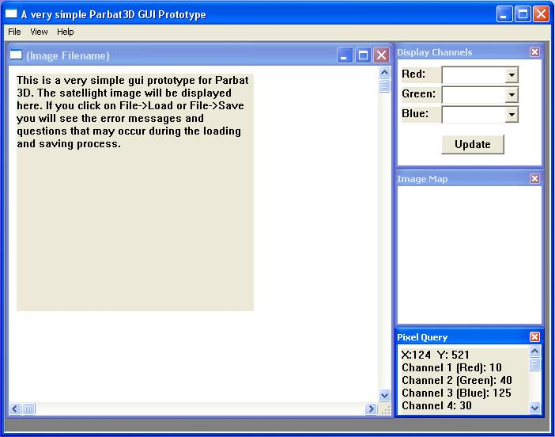

Feedback

Stuart Cook (BioDiv) on 6/4/2006
- Floating windows a bit clattered – perhaps main window with sidebars.

Status
Approach abandoned

Stage 4

Description
To improve on the usage of screen space, this prototype is now based on stage 1 and has separate windows with the image window as the main control point. To further reduce screen space the channel selection and pixel query windows have been combined.
Stage | Previous Stage | Developer
4 | 1 | Matt
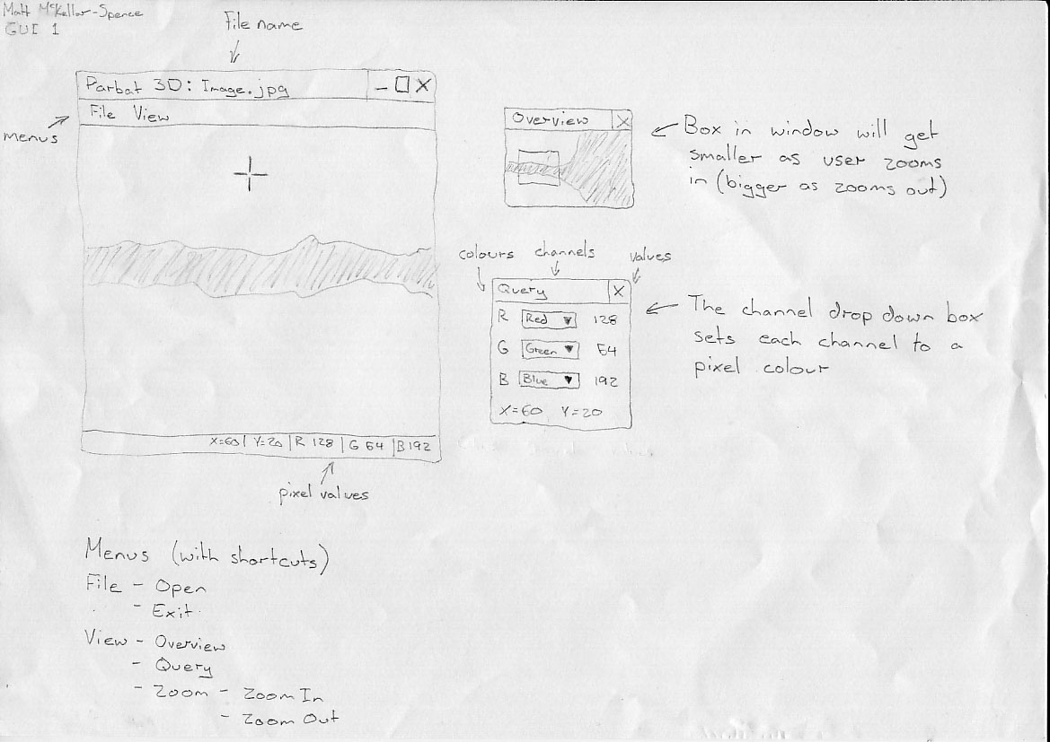

Feedback

Karl Fischman on 6/4/2006
- Overview is good and design is very ‘clean’

Abdal Chambal (eXation) on 6/4/2006
- Break query window into two - channels & pixel query

Status
Another stage required

Stage 5

Description
This prototype implemented stage 4 in an executable version to give an idea of what it would be like compared to the executable version of stage 3. Along with having separate windows this prototype also moved control from the image window to the overview window. This means the program is prepared for future improvements that would allow multiple image windows to be open. To improve the visibility of the information the channel selection and pixel query windows are still in the same window but now under different tabs.
Stage | Previous Stage | Developer
5 | 4 | Rowan
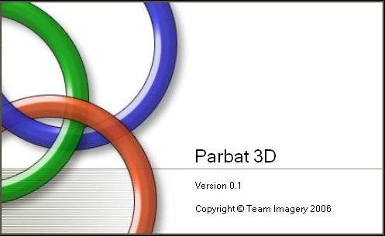
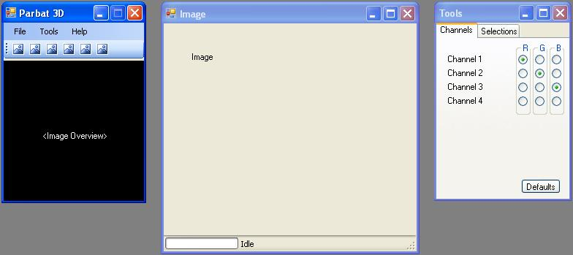

Feedback

Thai Nguyen (GetSet) on 10/4/2006
- “The icon buttons are good & the splash screen is nice as well”

Francis Chui (Krill) on 6/4/2006
- “Docking would be a good feature for all the additional (tool) windows”

Status
Approved by most people and finished

